ML Lab 4

Name: Saptanshu Wanjari

Class: A-A2

Roll No: 18
Lab No.: 4
Lab Aim and Objective: To classify wine quality using a Decision Tree Classifier on the Wine Quality dataset, including data preprocessing, exploratory data analysis, model training, and evaluation.
Dataset or Resources Used: winequality-red.csv - 1599 samples of red wine with 11 physicochemical features and a quality rating (3-8). 240 duplicate rows removed, leaving 1359 samples.
Date of Performance: 19 August 2025

1. Theory

1.1 What is a Decision Tree?
A Decision Tree is a supervised learning algorithm that splits data recursively based on feature thresholds. At each node, the feature and split point that maximize information gain are selected. Common impurity measures include Gini impurity and entropy. Trees are easy to interpret but tend to overfit without pruning.

1.2 Decision Tree for Classification
For classification, the tree assigns the majority class of training samples in each leaf node. The algorithm recursively partitions the feature space until stopping criteria are met. Key hyperparameters include max_depth, min_samples_split, and min_samples_leaf.

1.2 Techniques Applied
• Information Gain / Entropy: Measures reduction in uncertainty after splitting on a feature.
• Gini Impurity: Probability of incorrectly classifying a randomly chosen sample.
• Overfitting control: Pruning (pre-pruning via max_depth, min_samples_leaf; post-pruning via cost-complexity).
• Feature scaling is not required for tree-based models as splits are threshold-based.

2. Code with GitHub URL
The complete code for this lab is written in a Jupyter Notebook and uploaded to GitHub:
https://github.com/SaptanshuWanjari/3rd-Year-.git/blob/main/ML/lab/12-8-Lab4-Winequality/Lab_4_A_18_Saptanshu Wanjari.ipynb
https://github.com/SaptanshuWanjari/3rd-Year-.git/blob/main/ML/lab/12-8-Lab4-Winequality/Lab_4_A_18_Saptanshu Wanjari.py
The complete written code is given below:
#!/usr/bin/env python
# coding: utf-8
# # ML Lab 4
# ## Name: Saptanshu Wanjari
# ### Class: A A2
# ### Roll No: 18
#
# In[1]:
import pandas as pd
import numpy as np
import seaborn as sns
import matplotlib.pyplot as plt
# In[2]:
df=pd.read_csv("winequality-red.csv")
# In[3]:
df.head()
# In[4]:
df.tail()
# In[5]:
df.info()
# In[6]:
df.describe()
# In[7]:
df.isnull().sum()
# In[8]:
df.duplicated().sum()
# In[9]:
df=df.drop_duplicates()
# In[10]:
df.duplicated().sum()
# In[11]:
df.columns
# ## Univariate Analysis
# In[12]:
numeric_cols=df.columns
for col in numeric_cols:
plt.figure(figsize=(7,4))
sns.histplot(df[col],kde=True)
plt.title(f"Distribution of {col}")
plt.xlabel(col)
plt.ylabel('Frequency')
plt.show()
# In[13]:
for col in numeric_cols:
plt.figure(figsize=(7,3))
sns.boxplot(x=df[col])
plt.title(f"Boxplot of {col}")
plt.show()
# In[14]:
df.describe().T
# In[15]:
plt.figure(figsize=(7,4))
sns.countplot(x='quality',data=df)
plt.title("Distribution of Wine quality")
plt.show()
# In[16]:
df['quality'].value_counts().sort_index()
# ## Bivariate Analysis
# In[17]:
sns.boxplot(x='quality',y='alcohol',data=df)
plt.title('Alcohol vs Wine quality')
plt.show()
# In[18]:
df.head()
# In[19]:
features=['fixed acidity','volatile acidity','citric acid','residual sugar','chlorides','free sulfur dioxide','total sulfur dioxide','density','pH','sulphates','alcohol']
for col in features:
plt.figure(figsize=(7,4))
sns.boxplot(x='quality',y=col,data=df)
plt.title(f"{col} vs Wine quality")
plt.show()
# In[20]:
features=df.drop(columns=['quality'])
Q1=features.quantile(0.25)
Q3=features.quantile(0.75)
IQR=Q3-Q1
lower_bound = Q1-1.5*IQR
upper_bound = Q3+1.5*IQR
outlier_mask=(features<lower_bound) | (features>upper_bound)
outlier_count = outlier_mask.sum()
outlier_percentage=(outlier_count/len(features))*100
outlier_summary=pd.DataFrame({
'Q1': Q1,
'Q3': Q3,
'IQR': IQR,
'Lower Bound': lower_bound,
'Upper Bound': upper_bound,
'Outlier Count': outlier_count,
'Outlier Percentage': outlier_percentage
})
outlier_summary.round(3)
# In[21]:
plt.figure(figsize=(12,6))
outlier_count.sort_values(ascending=False).plot(kind='bar')
plt.title("Number of outliers in each feature")
plt.xlabel("Features")
plt.ylabel("Number of outliers")
plt.xticks(rotation=45,ha='right')
plt.grid(axis='y',alpha=0.3)
plt.tight_layout()
plt.show()
# In[22]:
plt.figure(figsize=(7,4))
sns.countplot(x='quality',data=df)
plt.title("Distribution of wine quality")
plt.show()
# In[23]:
sns.scatterplot(x='alcohol',y='quality',data=df)
plt.title("Alcohol vs Wine quality")
plt.show()
# In[24]:
sns.scatterplot(x='volatile acidity',y='quality',data=df)
plt.title("Volatile acidity vs Wine quality")
plt.show()
# ## Multivariate Analysis
# In[25]:
plt.figure(figsize=(12,8))
corr=df.corr()
sns.heatmap(corr,annot=True,cmap='coolwarm',fmt='.2f')
plt.title("Correlation Heatmap")
plt.show()
# In[26]:
selected=['alcohol','volatile acidity','sulphates','citric acid','quality']
sns.pairplot(df[selected],hue='quality')
plt.show()
# In[27]:
df['quality_group']=pd.cut(df['quality'],bins=[0,5,6,10],labels=['Low','Medium','High'])
# In[28]:
sns.boxplot(x='quality_group',y='alcohol',data=df)
plt.title("Alcohol distribution across quality groups")
plt.show()
# In[29]:
sns.countplot(x='quality_group',data=df)
plt.title("Count of wines in each quality group")
plt.show()
# In[30]:
from sklearn.model_selection import train_test_split
from sklearn.tree import DecisionTreeClassifier, plot_tree
from sklearn.metrics import (accuracy_score,precision_score,recall_score,f1_score,classification_report,confusion_matrix,ConfusionMatrixDisplay)
# In[31]:
X=df.drop('quality',axis=1)
y=df['quality']
# In[32]:
print("X shape:",X.shape)
print("y shape:",y.shape)
# In[33]:
print(y.value_counts().sort_index())
# In[34]:
X_train,X_test,y_train,y_test=train_test_split(X,y,test_size=0.2,random_state=42,stratify=y)
# In[35]:
criterion='entropy'
# In[36]:
dt_model=DecisionTreeClassifier(criterion=criterion,random_state=42)
# In[37]:
df['quality_group']=pd.cut(
df['quality'],
bins=[0,5,6,10],
labels=['low','medium','high']
)
# In[38]:
print(X.columns)
# In[39]:
print(X.select_dtypes(exclude="number").columns)
# In[40]:
X=df.drop(columns=['quality','quality_group'],errors='ignore')
# In[41]:
X_train,X_test,y_train,y_test=train_test_split(X,y,test_size=0.2,random_state=42,stratify=y)
# In[42]:
from sklearn.preprocessing import StandardScaler
# ponytail: Decision Trees are scale-invariant, scaling is for workflow completeness
scaler = StandardScaler()
X_train_scaled = scaler.fit_transform(X_train)
X_test_scaled = scaler.transform(X_test)
print("Scaling applied using StandardScaler")
print("Note: Decision Tree models are invariant to feature scaling")
# In[43]:
print(X.columns)
print(X.dtypes)
# In[44]:
print("X_train: ",X_train.shape)
print("X_test: ",X_test.shape)
print("y_train: ",y_train.shape)
print("y_test: ",y_test.shape)
# In[45]:
dt_model.fit(X_train,y_train)
# In[46]:
dt_model.fit(X_train,y_train)
# In[47]:
y_train_pred=dt_model.predict(X_train)
y_test_pred=dt_model.predict(X_test)
# In[48]:
train_accuracy=accuracy_score(y_train,y_train_pred)
print("Training Accuracy: ",train_accuracy)
# In[49]:
test_accuracy=accuracy_score(y_test,y_test_pred)
print("Testing Accuracy: ",test_accuracy)
# In[50]:
print("Precision: ",precision_score(y_test,y_test_pred,average="weighted"))
print("Recall: ",recall_score(y_test,y_test_pred,average="weighted"))
print("F1 Score: ",f1_score(y_test,y_test_pred,average="weighted"))
# In[51]:
print(classification_report(y_test,y_test_pred))
# In[52]:
cm=confusion_matrix(y_test,y_test_pred)
plt.figure(figsize=(12,6))
sns.heatmap(cm,annot=True,cmap='coolwarm',fmt='d')
plt.xlabel('Predicted quality')
plt.ylabel('Actual quality')
plt.title("Confusion Matrix")
plt.show()
# In[53]:
print("tree depth: ",dt_model.get_depth())
print("number of leaves: ",dt_model.get_n_leaves())
# In[54]:
plt.figure(figsize=(25,15))
plot_tree(dt_model,feature_names=X.columns,class_names=[str(c) for c in sorted(y.unique())],filled=True,rounded=True,fontsize=8)
plt.title("Decision tree: Entropy")
plt.show()
# In[55]:
plt.figure(figsize=(24,12))
plot_tree(dt_model,feature_names=X.columns,class_names=[str(c) for c in sorted(y.unique())],filled=True,rounded=True,fontsize=8,impurity=True,precision=4,max_depth=3)
plt.title("Decision tree: Entropy")
plt.tight_layout()
plt.show()

3. Procedures and Materials Used

3.1 Materials Used
• Hardware: Laptop with 8 GB RAM, Intel i5 processor
• Software: Python 3.12, Jupyter Notebook, scikit-learn, pandas, numpy, seaborn, matplotlib
• Dataset: winequality-red.csv (UCI Machine Learning Repository)

3.2 Procedure
1. Loaded the Wine Quality dataset and inspected shape, data types, missing values, and duplicates.
2. Removed 240 duplicate rows, reducing the dataset from 1599 to 1359 samples.
3. Performed univariate analysis: histograms and box plots for all 11 numeric features.
4. Performed bivariate analysis: scatter plots and box plots of quality vs key features.
5. Performed multivariate analysis: correlation heatmap and pairplot of top features.
6. Grouped quality into low/medium/high categories for additional analysis.
7. Applied IQR-based outlier analysis across all features.
8. Applied StandardScaler for feature scaling (included for workflow completeness).
9. Split data into 80% training (1087 samples) and 20% testing (272 samples) with stratification.
10. Trained a DecisionTreeClassifier with default parameters.
11. Evaluated the model using accuracy, precision, recall, F1-score, confusion matrix, and tree visualization.

4. Output Screenshots with Descriptions

Output 1 - Dataset Overview
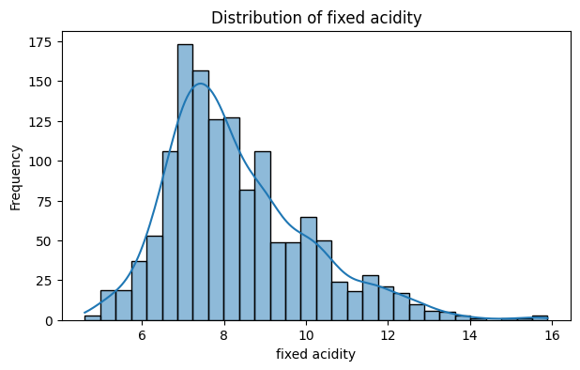
We loaded the dataset and checked its shape. It had 1599 rows and 12 columns. All features were numeric with no missing values.

Output 2 - Feature Distributions
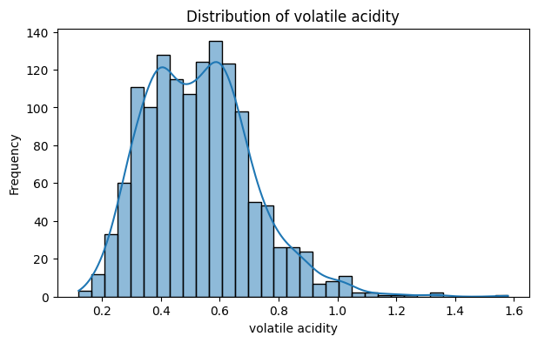
Histograms showed most features are right-skewed. Alcohol ranged from about 8 to 14 percent. Residual sugar and chlorides had notable outliers.

Output 3 - Outlier Analysis
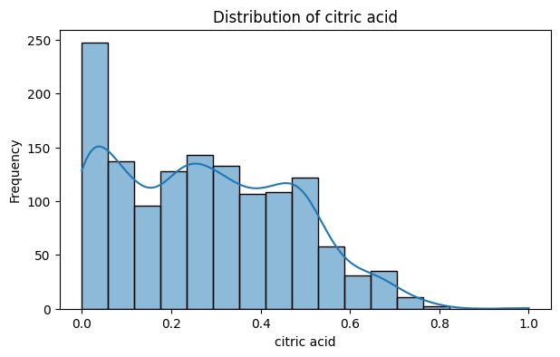
Box plots for each feature revealed several outliers, especially in residual sugar, chlorides, and sulphates.

Output 4 - Alcohol vs Quality
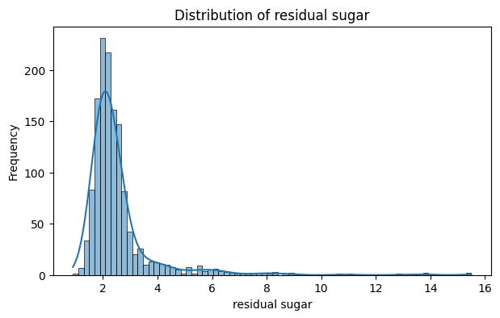
Scatter plot of alcohol vs quality showed a positive trend. Higher alcohol wines tended to have higher quality ratings.

Output 5 - Volatile Acidity vs Quality
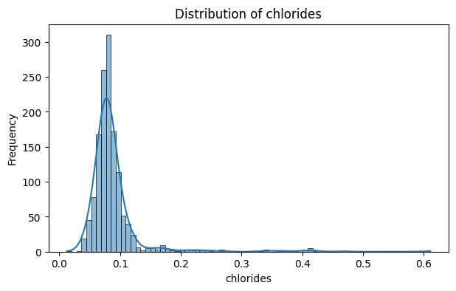
Volatile acidity showed a negative relationship with quality. Wines with high volatile acidity were mostly rated low.

Output 6 - Correlation Heatmap
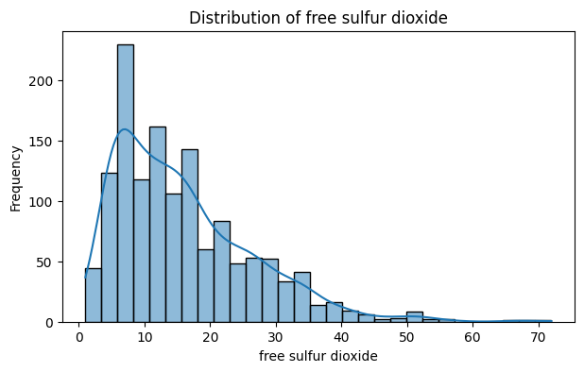
Alcohol had the strongest positive correlation with quality (0.48). Volatile acidity had the strongest negative correlation (-0.39).

Output 7 - Pairplot of Top Features
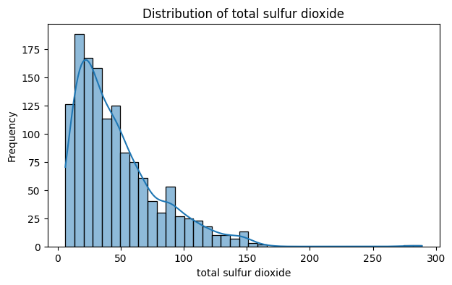
Pairplot of top features showed clear separations between quality groups for alcohol and volatile acidity.

Output 8 - Quality Group Analysis
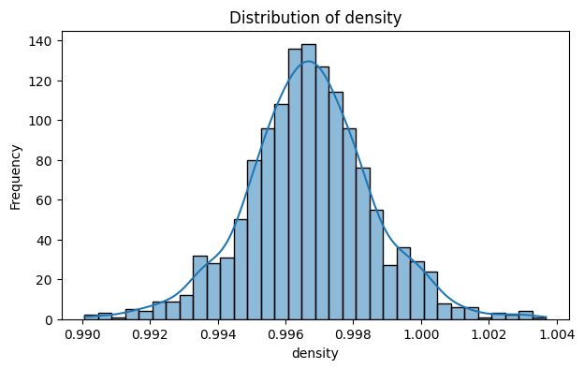
Box plot of alcohol across quality groups confirmed higher quality wines have higher median alcohol content.

Output 9 - Quality Distribution
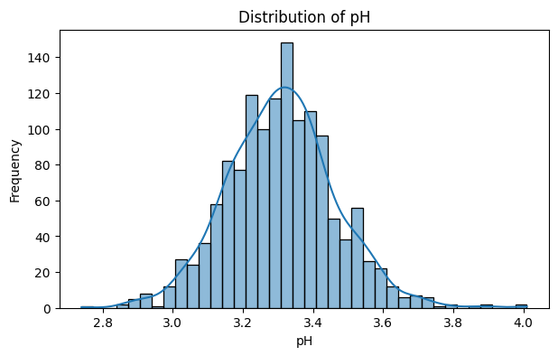
Most wines were rated 5 or 6. Very few were rated 3 or 8, making those classes hard to predict.

Output 10 - Confusion Matrix
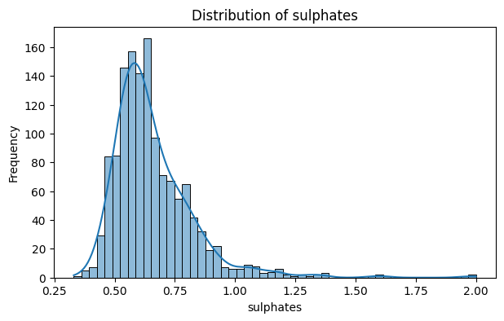
Good predictions for classes 5 and 6 but poor for minority classes 3, 4, 7, and 8.

Output 11 - Full Decision Tree
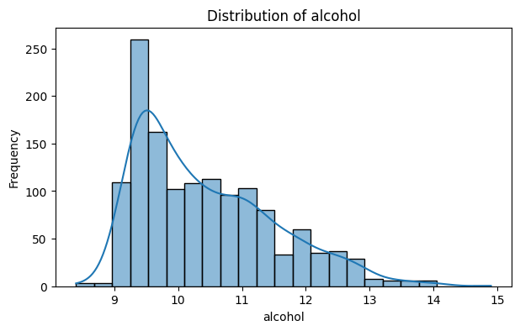
The full tree had depth 18 and 299 leaves. It memorized training data perfectly but overfitted.

Output 12 - Partial Decision Tree
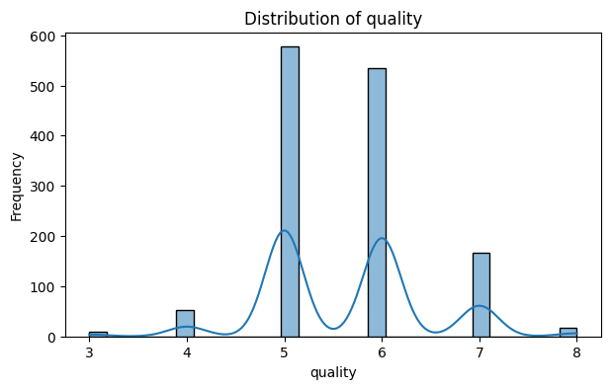
Top 3 levels showed alcohol, volatile acidity, and sulphates as the most important splitting features.

5. Viva Questions and Solutions
Q1. Why is feature scaling not required for Decision Trees?
Solution: Decision Trees split based on threshold values, not distances. The split point is determined by impurity reduction, so scaling does not change the tree structure.
Q2. Why is training accuracy 100% but test accuracy only ~50%?
Solution: This is overfitting. With no pruning, the tree memorizes noise. Depth 18 with 299 leaves is too complex. Use max_depth or min_samples_leaf to fix this.
Q3. What does the confusion matrix tell us?
Solution: The model predicts majority classes (5, 6) well but fails on minority classes (3, 4, 7, 8) due to class imbalance.
Q4. How would you improve this model?
Solution: Set max_depth, use min_samples_leaf, try class_weight='balanced', or use ensemble methods like Random Forest.
Q5. What is the difference between Gini and entropy?
Solution: Gini = 1 - sum(p_i^2), Entropy = -sum(p_i * log2(p_i)). Both produce similar trees. scikit-learn defaults to Gini.

